QRP Newsletter
Queens Road Partnership 387 Queens Road SE14 5HD
Spring Summer 2018
Online prescriptions
REGISTER NOW AT RECEPTION
You don’t have to come into the practice to order your repeat prescription. You can do this from the chemist where you usually collect them. Ask the Pharmacist if you want the Chemist to order your repeat items on your behalf from us. They will do this and then let you know when the items are ready to pick up. This takes 2 working days. Please note that there are some drugs that cannot be ordered by this service. Your pharmacist will advise.
Please be aware that we do not take prescription requests over the telephone.
You can request your medication online if you are registered with EMIS Patient Access to Electronic Records (PAER). You can do this at reception with some photographic ID.

In the very near future you can also view your results and Doctors comments relating to your results using EMIS Patient Access To Electronic Records.

Accessing appointments
We do not offer same day appointments(unless there are cancellations) but we could book you the next available one. Appointments are available for booking up to 4 weeks at the moment with both Doctors and Nurses. If you have an emergency that needs to be addressed on the same day we will offer the triage system, which is a same day telephone call back from the Doctor. The receptionist will take a brief account of the symptoms affecting you. This is necessary so that the Doctor deals with the most urgent cases first. We will take your number and the doctor will ring you back. Please keep your line free as you will only get one call back after the first one. After that the Doctor will leave you a message to contact us if you still need us.
If all appointments are full the Receptionist will signpost you to alternative urgent services including 111 , local walk in and urgent care services
A comprehensive list of the alternative services provided are on ‘The QRP Local Care Navigator’
Available at www.queensroadpartnership.co.uk
Repeat Sick notes
Please these are not urgent requests and often block the lines for other patients. Please accept that the note can be backdated for you depending on when the call was made and accept the routine telephone appointment reception will give you.
Please note we have a standard letter reception will give you if requested stating you are awaiting a doctors appointment which is acceptable to organisations.
Tardiness
Please arrive on time for appointments. We allow 10 minutes grace after which you will DNA. Please be on time out of respect for other patients. If you are late you will have to rebook.

Patient Participation Group
And finally…
If you are interested in helping to shape the future of the QRP such as where mentioned premises move …then get involved by joining our Patient Participation Group. They meet every 4 months at the clinic and are responsible for organising events and public meetings for patients. Historical activities have included organising a healthy eating day and sponsored walk from the surgery. Leave your details at reception and the PPG will get in touch. Alternatively email them directly:
queensroadppg@outlook.com

QRP

Emergency prescription requests
If you feel there is an emergency and you have run out of medication, YOUR DESIGNATED PHARMACIST will give you an EMERGENCY SUPPLY. The pharmacist is entitled to charge for this as per NHS guidelines.
Please hand in repeat script requests in good time (2 working days) allowing your usual doctor to review the request safely and efficiently. You will be directed to your pharmacy if you need an emergency supply.
Minor Ailments & Self Help
Common problems your pharmacist can help you with
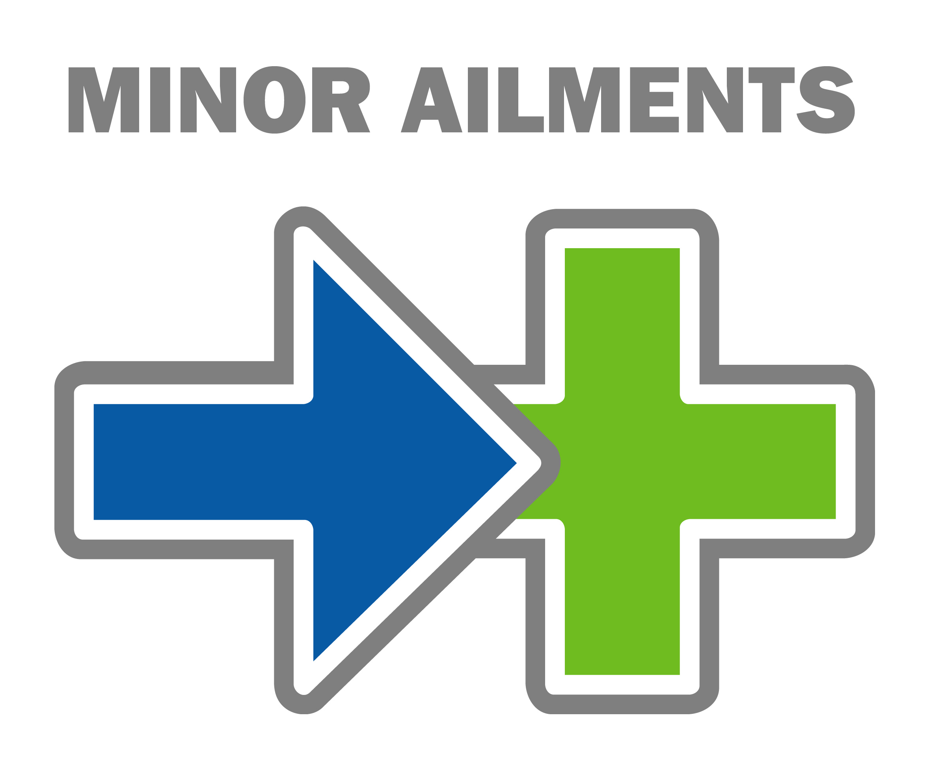
Skin conditions, such as mild acne and mild eczema, coughs and colds, including nasal congestion and sore throat, minor cuts and bruises
Constipation and haemorrhoids (piles) Hay fever and allergies
aches and pains, such as headaches, earache and back pain indigestion, diarrhoea and threadworms Period pain and thrush
warts and verruca’s, mouth ulcers and cold sores Athlete’s foot Nappy rash and teething . Some pharmacies also provide truss fittings, stoma products and incontinence supplies.
Every year, millions of us visit our GP with minor health problems that our local pharmacist could resolve.
It is estimated that every year, 50 million visits to the GP are made for minor ailments such as coughs and colds, mild eczema and athlete’s foot. But by visiting your pharmacy instead, you could save yourself time and trouble. Instead of booking and waiting for a GP appointment, you can visit your local pharmacist any time – just walk in.
All pharmacists can recognise many common health complaints. They can give advice or, where appropriate, medicines that will help clear up the problem. If your problem is more serious and needs the attention of a GP, your pharmacist will recognise this and advise you to see your GP instead. What’s more, many pharmacies are open in the late evenings and on the weekends.
If everybody went to a pharmacist with common health problems, more time would be freed up for our GPs. This might make it easier to get a convenient appointment with your GP next time you need one. So, if you have a common health problem, a trip to your local pharmacy is an option.

