+ Office use only
Pt Informed Named GP | Yes  Usual GP:
ID seen for Online Access by
Routine HC Advise given i.e smears / imms
Patient Information
Date
First Name
Surname
Date of Birth |  | Previous GP Name:
Your NHS |  |  | If this is your 1st registration with NHS then enter the date came to UK:
Your Current Address
Mobile No
Email
Occupation

Preferred method of communication:
Consent to receive SMS Notification for Clinical Service Y/N
Consent to receive EMAIL Notification for Clinical Service Y/N

Carers Information
Do you look after someone who is ill, frail or disabled? Yes/No

Are you a carer? Yes/No

Do you have a carer? (Does someone look after you?) Yes/No
If yes, please tell us their name and telephone number

What is their relationship to you?

Next of Kin
Relationship to you:

Title: Name:

Contact No:

We would only contact your next of kin in an emergency. We do not divulge confidential information to anyone without your permission.

I give consent for the practice to access my medical information from hospitals and previous doctors if necessary for my medical care.

Signature | Date

Our GP Online Service
Would you like to sign up for Patient Access allowing you to book appointments & order repeat prescriptions on-line? Yes No
Please read the Do It Online Leaflet for further information

Life Style Data
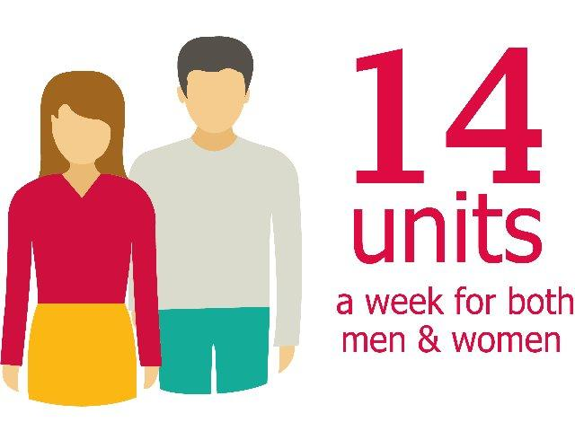
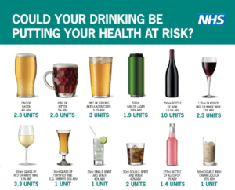
Please answer the following questions which are widely used as screening tools for alcohol use
Questions | Scoring System |  |  |  |  | Your Score
 | 0 | 1 | 2 | 3 | 4
How often do you have a drink containing alcohol | Never | Monthly or Less | 2-4 times per month | 2-3 times per week | 4+ times per week
How many units of alcohol do you drink on a typical day when you are drinking? | 1 to 2 | 3 to 4 | 5 to 6 | 7 to 9 | 10+
How often have you had 6 or more units if female or 8 or more if male, on a single occasion in the last year? | Never | Less than Monthly | Monthly | Weekly | Daily or almost daily
 |  |  |  |  | TOTAL:
A score of less than 5 indicates lower risk drinking.

Lifestyle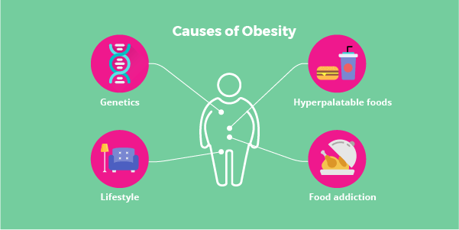

Height: m/feet Weight: Kg/Stones

Waist Circumference …………………………………………………inches/cm

Are you a smoker? Yes, cigarettes How many? daily/weekly
Yes, cigars How many? daily/weekly
Yes, pipe oz/grams of tobacco? daily/weekly
Stopped smoking How long ago?
No, never smoked
Do you use an e-Cigarette yes no Ex-user

Would you like help to stop smoking? Yes

Do you have any  special needs? | Yes/No If Yes, Please state:
Are you registered disabled? | Yes/No

Medical History
- Do you suffer from any Long term Conditions? EG: Asthma, Epilepsy, or high blood pressure? Y/N
- Have you had any serious illness that were treated in hospital? Please give details including dates when possible. For example: Heart attack, Stroke, Cancer.

Other? Please state

Family Medical History – Has any family member/s suffered from the following?

Adult Immunisations – Please give date of last vaccination for:

Tetanus | Yes/No Date:
Rubella/German Measles (Women only) | Yes/No Date:
Other

Medications – Are you taking any drugs or medicines? Yes/No

Allergies – Are you allergic to any medicines Yes/No
If yes, which ones? And what happens if you take them?

Have you been in hospital with a serious illness/operation?

Exercise – Do you take exercise? If so, what? And how often?

Signature of patients Signature on Behalf of Patient

- - -- - - - - - - - - -- - - - - - - - - - - - - - - - - - - - - - - - - -
Date - - - - - - - - - - - - - - - -

HIV
We have a high rate of HIV infection compared to the London and England average. As of 2018, our rate of diagnosed HIV is 8 in 1,000 residents. This is the 6th highest of a London borough. Estimates suggest that one in five people in London with HIV do not know that they have it. As of 2018, 44% of people in the borough diagnosed with HIV are diagnosed late and are already unwell.
You can find more information about HIV and AIDS in Lewisham routine testing here
https://www.lewishamandgreenwich.nhs.uk/latest-news/hiv-testing-in-uhl-is-huge-success-09122019-1966/
If you like a test please speak to a receptionist

Refusal: If despite medical recommendations if you do not want to have a test done then please let us know and we will make a record of it

HIV test offered Y/N. HIV test Declined Y/N

Patient Signature_________________ Date___________________________

Female Patients only

Cervical Smear Data
Have you had a smear test? | Yes/No
Date of last smear?
Clinic/Surgery where smear taken?
Result of smear? | Normal/Abnormal/Inadequate
Any history of abnormal smear?
Next smear due?

Eligible women for Smear

Women are included in the cervical screening programme for the age of 25 to 64.

If you have not had a smear test in the last 3 or 5 years then please make an appointment with one of our practice nurse as soon as possible.

Having cervical screening at the recommended interval provides a low risk status rather than a no risk status of developing cervical cancer.

A Cervical Information Booklet is available in English and number of other languages, you can find them on the NHS web site at: http://www.cancerscreening.nhs.uk/cervical/

Contraception

Please let us know the method of family planning/contraception you use

Do you take the oral contraceptive pill? Yes No
Have you been fitted with an IUCD (coil)? Yes No
If yes, when? …………………
Have you been fitted with an implant? Yes No
If yes, when? …………………
Have you had a hysterectomy? Yes No
If yes, when? …………………

Breast screening

Have you had a mammogram? Yes No
If yes, when?

Breast screening is offered to all women aged between 50 and 70 every three years. Breast screening (Mammography) is the most reliable way of detecting breast cancer at an early stage which saves an estimated 1,400 lives each year. Every year around 11,500 people die from breast cancer in the UK. To find out more visit: www.cancerscreening.nhs.uk

To book for your Breast Screening appointment please call 020 3299 1964

Ethnic Background/Origin

Please select what you consider your ethnic origin to be. Ethnicity is not the same as your nationality. For example, many of our patients whose nationality is British may also be from different ethnic groups such as Irish, Caribbean or Bangladeshi. It is important to us that you describe your own ethnic background/origin.

- ASIAN OR ASIAN BRITISH | Please tick as appropriate | D. MIXED | Please tick as appropriate
Indian |  | White & Black Caribbean
Pakistani |  | White & Black African
Bangladeshi |  | White & Asian
Any other Asian background. Please write in: |  | Any other Mixed background. Please write in:
B. BLACK OR BLACK BRITISH | Please tick as appropriate | E. WHITE | Please tick as appropriate
Caribbean |  | British
African |  | Irish
Any other Black background. Please write in: |  | Any other White background. Please write in:
C. CHINESE OR OTHER ETHNIC GROUP | Please tick as appropriate | F. DECLINED |  | Please tick as appropriate
Chinese |  | I do not wish to give this information
Any other. Please write in: |  | Please help us to understand why you have chosen not to disclose this information:
Main Language. |  | Interpreter needed YES/NO

You are under no obligation to complete this questionnaire

Data Protection: Please be assured that the information you provide will remain anonymous and will only be stored in your medical record held by the practice. All details are held in accordance with the Data Protection Act 1998
March/April 2020

